**NAME:…………………………………………………………**

**BRIGHT FUTURE BWEBAJJA SECONDARY SCHOOL**

**END OF TERM II EXAMINATIONS 2023**

**S.2 PHYSICS**

**PAPER 1**

**2 HOURS**

**INSTRUCTIONS:**

Section **A** has **10** Numbers **each** carrying **5** marks

Section **B** has **1** Number which is **compulsory**

Neatness is a **must** (1 mark **will** be lost for each untidy work

Answer in only spaces provided in section **A**

**SECTION A**

1. Below is a picture showing a Arnold running up stairs

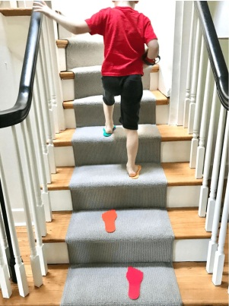

The boy does “5J for every second” as he is running up stairs.

(i)What physics term can be used to mean “5J for every second” (1mark)

………………………………………………………………………………………………………………………………………………………………………………

(ii)If the height of each stair is 50cm, how long will he take to reach to the 20thstair. Given that his weight is 60N. (4marks)

………………………………………………………………………………………………………………………………………………………………………………………………………………………………………………………………………………………………………………………………………………………………

1. In picture A, A small pin was placed on a paper and then the paper was placed on water. In picture B, surface yet the paper sinked.

(a)Explain why

(i) paper sinked (1mark)

………………………………………………………………………………………

(ii)Small pin remained on top (1mark)

………………………………………………………………………………………

(b)What do you think would have happened if a drop of liquid soap was added to water (2marks)

………………………………………………………………………………………………………………………………………………………………………………

(c)Give any real life Application (important) of the above mechanism. (1mark)

………………………………………………………………………………………………………………………………………………………………………………

1. Below is a flask you are required to study it and answer the questions that follow.

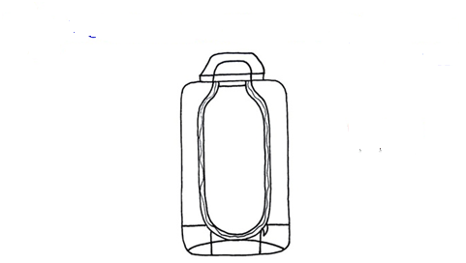

**C**

**B**

**A**

(a)Name the parts labeled A,B,C (2marks)

……………………………………………………………………………………………………………………………………………………………………………………………………………………………………………………………………..

(b)Explain how a flask is able to keep hot coffee tea hot for some time. (3marks)

………………………………………………………………………………………………………………………………………………………………………………………………………………………………………………………………………

1. In figure below, a man pushing a wheelbarrow of weight $10N$ having sand of mass $70Kg$ up to the second floor of the house.

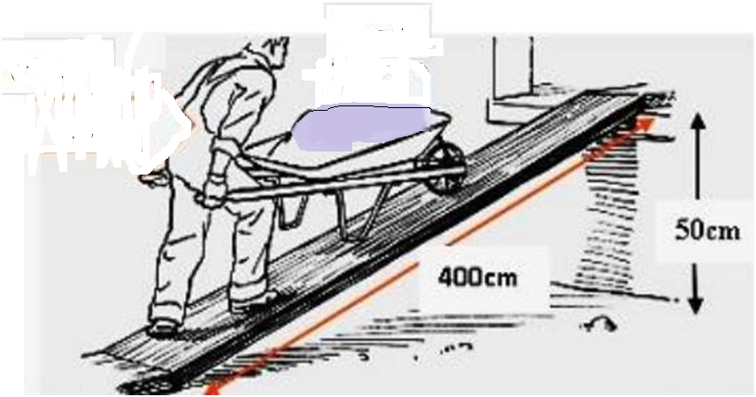

(ii)If the efficiency of the machine is 80%, calculate:

(i)velocity ratio. (01mark)

………………………………………………………………………………………………………………………………………………………………………………………………………………………………………………………………………

(ii)mechanical advantage (02marks)

………………………………………………………………………………………………………………………………………………………………………………………………………………………………………………………………………

(iii)Energy wasted (02mark)

………………………………………………………………………………………………………………………………………………………………………………………………………………………………………………………………………

1. Below is a system of force acting on the body mass 5Kg

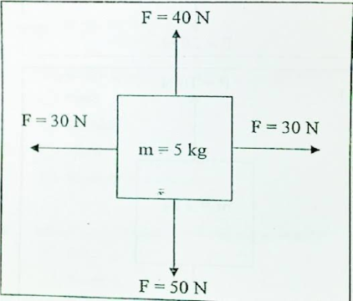

(a)Calculate the resultant force on the body (03marks)

………………………………………………………………………………………………………………………………………………………………………………………………………………………………………………………………………

………………………………………………………………………………………

(b)Forces are categorized by contact forces and non-contact forces. With examples give a reason why the forces are called so. (02marks)

………………………………………………………………………………………………………………………………………………………………………………………………………………………………………………………………………

……………………………………………………………………………………………………………………………………………………………………………..

1. Below is a bell on a flat surface and a dark region is formed on the floor when the ball is touched.

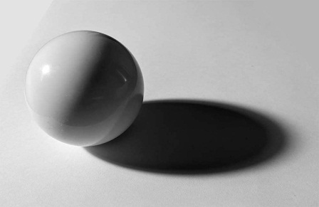

1. (i)What property of light is in that situation (1mark)

…………………………………………………………………………………

(ii)What name is given to the dark region formed? (½mark)

………………………………………………………………………………………

1. When you view an object through certain materials, there through which you cannot see anything, some you can see but not clearly and others you can see clearly. That means light can pass through dome materials and others cannot. You are required to give the categories of those objects and give the differences in the table below. (3marks)

|  |  |  |
| --- | --- | --- |
| Category | Example | Effect on light |
|  |  |  |
|  |  |  |
|  |  |  |

1. Kato was buying a gold watch worth 20,000ugsh from a friend. But he is worried because of bad rumors which have been moving around the city about the watches sold by a friend i.e. they are not pure gold. The friend is convincing him that the watch is gold.

(a) In brief, how can Kato avoid being cheated (2marks)

………………………………………………………………………………………………………………………………………………………………………………

(b)If the mass of his watch is and the volume is

(i)What is the density of Kato’s watch? (2marks)

………………………………………………………………………………………………………………………………………………………………………………

(ii)Should Kato pay the money? Support your answer. (1mark)

………………………………………………………………………………………………………………………………………………………………………………

1. Kato went to the hospital and his body temperature was found to be 300c.

(a)What is the significance of temperature in real life? (1mark)

………………………………………………………………………………………………………………………………………………………………………………

(b)During construction of thermometer, thermometric properly is considered.

You are required to give at least 2 examples of thermometric property (2marks)

………………………………………………………………………………………………………………………………………………………………………………

(c)The length of the mercy thread of a thermometer at ice point is 22cm and that at steam point is 62cm. calculate the reading of the thermometer when the mercury thread is 42cm long. (2marks)

………………………………………………………………………………………………………………………………………………………………………………………………………………………………………………………………………

1. An astronaut below moved to the moon from the earth. Below is a picture showing the astronaut on moon.

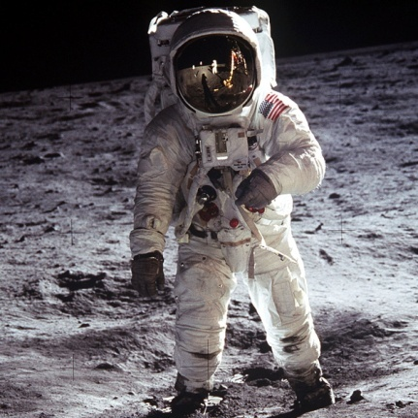

When he was on moon, he felt a reduction on how heavy he was. While on earth.That his weight was less that when on moon.

(i)Give a reason why there was a difference. (1mark)

………………………………………………………………………………………………………………………………………………………………………………

(ii)If the acceleration due to gravity on earth is $10ms^{-2}$ and on the moon is $1.67ms^{-2}$, What is the man’s weight on moon given that the man’s weight on earth is $400N$? (4marks)

………………………………………………………………………………………………………………………………………………………………………………………………………………………………………………………………………………………………………………………………………………………………

1. Most substances expand when they are heated. A balloon may become several times larger when it is heated. Solids expand so little that is hard to measure. Gases expand almost 3,000 times more than solids when they are heated over the same amount of temperature.

(a)Expand why this happens (3marks)

………………………………………………………………………………………………………………………………………………………………………………………………………………………………………………………………………

(b)Transmission cables (wires) are normally not pulled tightly during installation but are loosely held or have loops of various intervals over long distances as shown below.

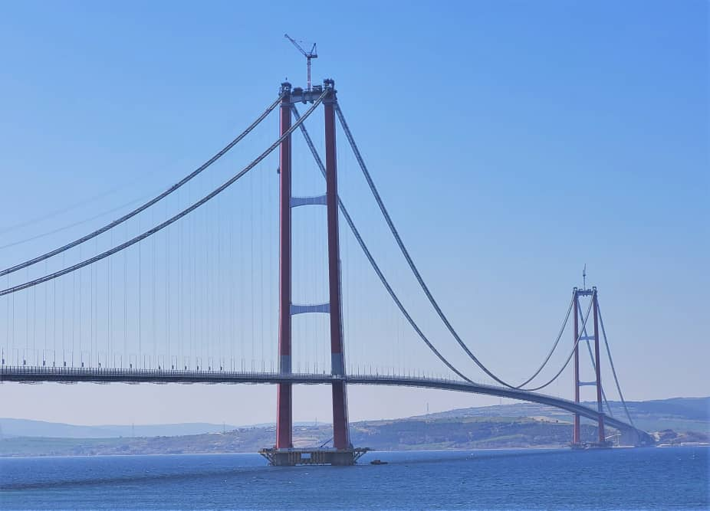

(b)Explain why it is left to sag (2marks)

………………………………………………………………………………………………………………………………………………………………………………

1. On a hot day, a student dropped three ice cubes at -6 ℃ in a jug of water at room temperature. If the final temperature of the mixture after all the ice has melted was 16 ℃,
2. Sketch a temperature-time graph for the ice. (2 mark)
3. Describe the key features of your graph in (i) above. (3marks)

……………………………………………………………………………………………………………………………………………………………………………………………………………………………………………………………………………………………………………………………………………………………………………………………………….

**END**